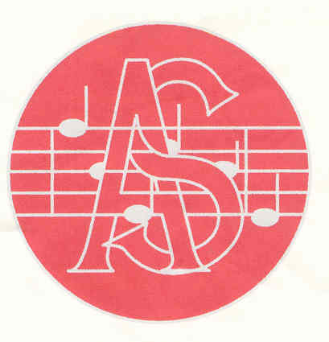

**Alcester Singers Young Musician of the Year 2024**

**Friday 22nd November at 7pm**

**St Benedict’s High School, Kinwarton Road, Alcester B49 6PX**

Once again we are pleased to announce our above competition which is open to all young musicians living or attending school within 10 miles of Alcester and are between 11 and 18 years of age at 31st August 2024.

**Rules**

* Previous winners are not eligible.
* Competitors must have achieved Grade 5 to be considered.
* A panel of three adjudicators whose decision is final will be appointed.
* Competitors should perform a piece or pieces of their own choice a copy of which must be given to the judges on the evening of the performance. A time limit of 7 minutes for each competitor will be applied.
* If an accompanist is required, competitors must provide their own.
* A prize of £200 will be awarded to the winner to be used in the furtherance of their music studies together with the Trophy to be held for one year. The winner will be expected to perform at one or more of Alcester Singers’ concerts.
* Entry form to be sent to [youngmusician@alcestersingers.co.uk](mailto:youngmusician@alcestersingers.co.uk) by the closing date of **Friday 8th November 2024**. Details for payment of the £5 entry fee will be sent on receipt of completed entry forms.
* Due to time restrictions on the evening, we are limited to accepting 12 entries only so early application is advised.
* This competition is sponsored by The Howarth Memorial Fund.